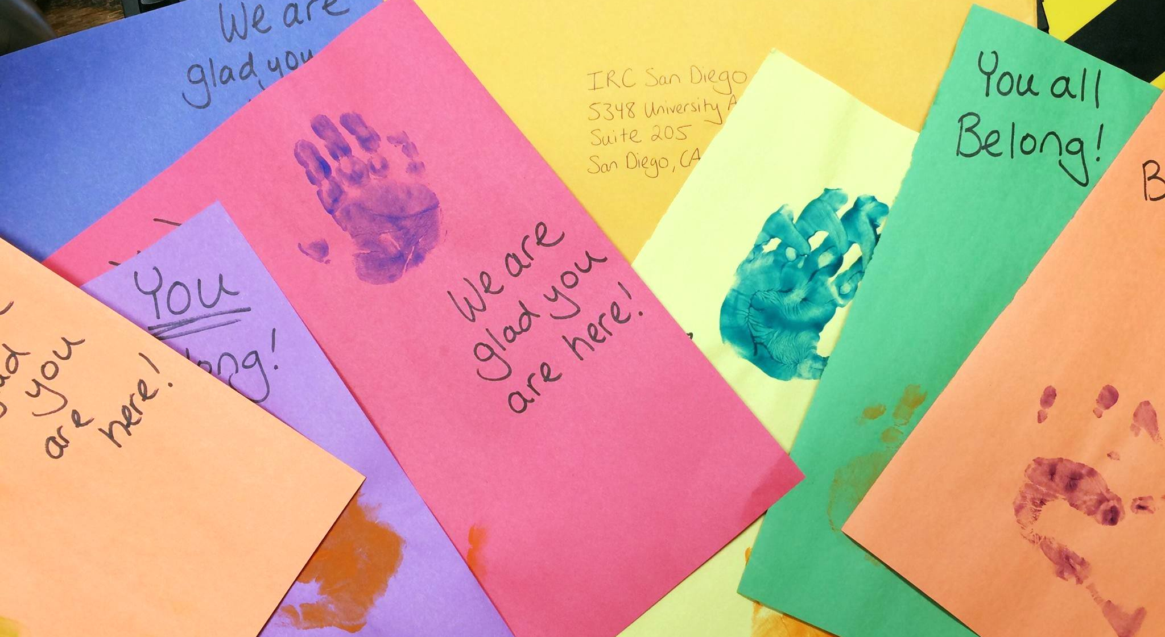
We are organizing a gift card drive in partnership with the International Rescue Committee to help support refugees who recently arrived in our community.
Gift Card Drive

Saturday, Month 31, 200912:30–2:00pm  At Event Place  Location Address 1  Location Address 2 | Please help recently arrived refugees in San Diego by donating a gift card:  - Walmart or Target  - $10, $25 or $50 value  - If you wish, include a note of welcome for the recipient!

Questions? Contact: | Contact Lastname  Contact.Lastname@Rescue.org  or call +1 619 641 7510 x000

