“The record drought in East Africa as well as the long-term effects of the economic downturn from the COVID-19 pandemic is putting women and girls at higher risk of violence…we are seeing double the number of cases of violence reported in the most recent year than in previous years...On the ground, women and girls are sharing that the cases of violence specifically targeted against younger girls have increased compared to other periods.”
Kurt Tjossem, Regional Vice President for East Africa at the IRC
CONTEXT

Gender Based Violence (GBV) is a global challenge. It takes many forms including intimate partner violence (“domestic abuse”), sexual violence and forced marriage, and is present in every society across the world. Women and girls are disproportionately impacted by GBV. It takes place in their homes, communities and places of work. It inhibits their economic, social, and political freedoms and stops women and girls from reaching their full potential.

Over one-third of women and girls globally will experience some form of violence in their lifetime. This rate is higher in emergencies, conflict, and crisis, where vulnerability and risks are increased and most often family, community, and legal protections have broken down.

The COVID-19 pandemic created an additional risk of GBV as humanitarian access was impacted and vital resources diverted away from life-saving services for women and girls. Across three regions in Africa where the IRC works (Great Lakes, East Africa, West Africa), 73% of women interviewed reported an increase in intimate partner violence, 51% cited an increase in sexual violence and 32% observed a growth in the levels of early and forced marriage during the COVID-19 pandemic.

The universal root cause of all GBV is gender inequality, or unequal power relationships between women and men. It is only by protecting and empowering women and ending gender inequality that can we address GBV at its root.

WHAT HAS THE UK GOVERNMENT DONE?

Historically, the UK Government has been one of the biggest donors to international programs supporting women and girls. The former Foreign Secretary, Liz Truss, has personally committed to putting women and girls at the heart of the Government’s foreign policy and the new International Development Strategy (IDS) reiterates this, committing to driving international action to end all forms of gender-based violence by:

- scaling up proven approaches to prevent violence – in homes, schools, workplaces, communities, and online.
- putting survivors at the heart of their approach and prioritising those most at risk, including adolescent girls, women and girls with disabilities, and LGBT+ individuals.
- driving a new global consensus on ending violence against women and girls, and lead globally on women, peace and security.

However, reductions to the UK’s ODA budget mean there has been a significant reduction (£1.6bn) in the UK’s gender-relevant spending, as well as a gradual reduction in the proportion of aid funding going to women’s organisations, presenting challenges to the UK’s commitments.

CHALLENGES

Rising numbers of conflicts globally are driving an increase in GBV. At present, there are more active conflicts than at any time since World War II, driven by an unprecedented growth in international internal conflicts. This in turn is exposing women and girls to heightened levels of violence, as the protracted nature of conflicts normalises GBV.

Efforts to tackle GBV are consistently underfunded. Between 2018 and 2021 less than a third of GBV funding requirements were met each year. Over the same period, 87% of gender-specific international humanitarian assistance came from just 10 donors, meaning a cut from just one donor — such as the UK last year — could considerably impact efforts to tackle GBV.
There is a lack of transparency for GBV prevention and response funding, especially for local and women-led organisations. Not only are GBV initiatives underfunded in humanitarian appeals, there's also a lack of transparency about humanitarian spend on GBV​. The role of local and national implementers of GBV services is more important than ever – yet funding to women’s rights and women-led organisations remains miniscule. These types of organisations are critical in providing the types of services required to empower and protect women.

WHAT MORE CAN THE UK GOVERNMENT DO?

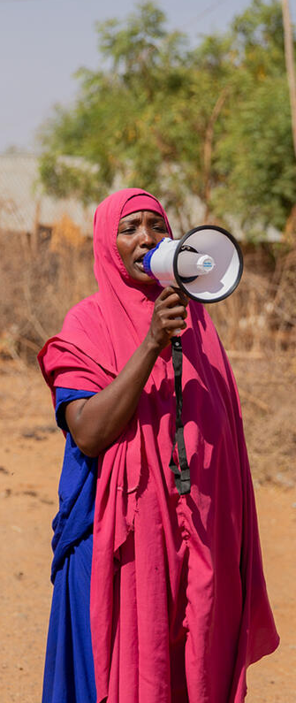
- Publish the Women and Girls Strategy

- We welcome the FCDO’s commitment to restore the women’s and girl’s ODA budget to pre-cut levels, however, we need more detail on how the Government plans to utilise this budget to re-establish Women’s and Girls programmes.
- The Government should ensure the Strategy includes a strong commitment on GBV prevention and response programming, ensuring fragile and conflict affected state are prioritised.

- Prioritise local and women-led organisations in humanitarian response

- Strong engagement with and investment in national and local women’s organisations is vital to tackle gender-based violence. The Government should work with multilateral organisations that are recipients of UK Aid to ensure funding is reaching local women’s organisations.

- Prevent GBV by increasing funding to gender equality programs

- The Government should utilise the newly reinstated women and girl’s ODA budget to prevent GBV from occurring in the first place by increasing funding to gender equality programmes and as soon as possible, reinstating 0.7%.
- In addition, it is critical to improve the quality of funding available – this means creating long-term, multi-year and flexible funding to women’s rights organisations which will help them put in place more effective and strategic interventions and cover their core expenses, including staffing and overhead costs.

The IRC’s Work Tackling Gender-Based Violence

The IRC takes a comprehensive approach to GBV through women’s protection and empowerment. We support the pursuit of a world where women and girls live free from violence as valued and respected members of their community.

With programmes in over 40 countries across Africa, Asia, Europe, the Middle East, and the U.S., the IRC delivers innovative programs focused on preventing and responding to GBV.

This includes being a key consortium member of the FCDO’s What Works to Prevent Violence: Impact at Scale What Works programme, which champions feminist principles and accountability to women and girls. We have also been working closely with the FCDO on efforts to tackle conflict-related sexual violence.

For more information, contact Claudia Craig, Senior Advocacy Officer, IRC-UK: Claudia.Craig@rescue.org

