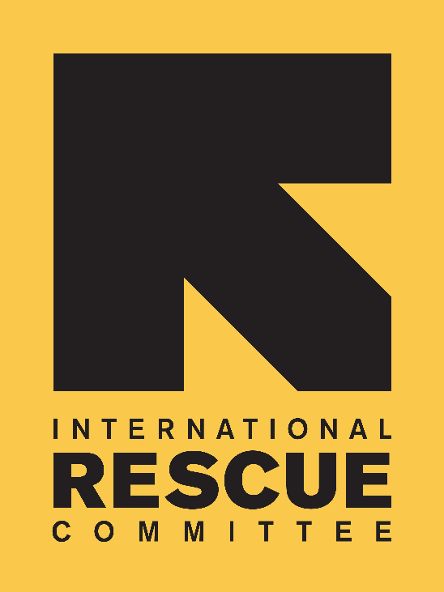
JOB DESCRIPTION

Position: Strategic Partnerships Officer
Reports to: Deputy Director, Strategic Partnerships - Europe
Location: London
Salary: circa £28,000 per annum
Hours: 37.5 hours per week

IRC Background
Over the past 80 years, the International Rescue Committee (IRC) has developed unparalleled expertise in responding to emergencies and helping uprooted communities to rebuild. Founded in 1933 at the request of Albert Einstein, the IRC’s mission is to help people whose lives and livelihoods are shattered by conflict and disaster to survive, recover, and gain control of their future. The International Rescue Committee UK is part of the IRC global network, which has its headquarters in New York and London. The IRC is on the ground in more than 40 countries, providing emergency relief and rebuilding lives in the wake of disaster. Through 28 regional offices in cities across the United States, the IRC also helps refugees resettle in the US and become self-sufficient. The IRC is committed to a culture of bold leadership, innovation in all aspects of our work, creative partnerships and, most crucially, accountability to those we serve. The IRC is a tireless advocate for the most vulnerable.

IRC-UK
Our European headquarters, IRC-UK, were established in London in 1997 to support the organisation’s global activities and particularly to diversify its donor base and be able to better advocate with European policy-makers on behalf of the people we serve. Since its establishment IRC-UK has grown rapidly and is now acknowledged for its high quality project management, technical expertise in governance and rights and economic recovery, and innovative thinking on early recovery and gender based violence. The IRC also has offices in Brussels, Berlin and Geneva. IRC-UK comprises approximately 90 staff across five departments.

The Global Awards Management Unit (AMU)
Established in January 2016, the Global Awards Management Unit (AMU) is a global unit spanning New York, Washington DC, London, Nairobi and Amman. It has responsibility for identifying, securing and managing all funding from statutory donors. The Unit is organized into five directorates: Strategic Partnerships & Analytics; Grants Management & Frameworks; Compliance and Policy; Business Development; and Training & Curriculum Design. Regional Grants Directors (RGDs) will support the “Grants Management & Frameworks” directorate.

The Global AMU is a bridge between donors and the field: providing expert technical advice to the field, while maintaining portfolio-level visibility to ensure consistency and compliance, and manage risk. This unit ensures that donor compliance policies and procedures are implemented consistently, and supports all staff working across the grants management cycle for all restricted funding from global government sources. The unit operates within a matrix management system across the teams in the US and the UK, driving functional integration between all relevant units and staff, in collaboration with the Vice President of the Global AMU and the Senior Vice President for Europe in relation to overarching issues with European donors. The matrix management structure ensures that AMU staff support the Europe strategy and work towards the pursuit of new opportunities, while IRC UK maintains accountability for European funding.

The Global AMU reports into the IRC’s Global Partnerships and Philanthropy Department (GPP) and contributes to the mission of the IRC by ensuring the growth and sustainability of public funding.

The GPP department is responsible for the global delivery of the International Rescue Committee’s financial resources, and plays an important strategic role in the creation of its brand, awareness and support for its advocacy goals. The IRC's 2020 Strategy centers on its ambition to continue to improve the scale and effectiveness of IRC programs worldwide with evidence of what works best to impact people’s lives in conflict and fragile settings. GPP comprises colleagues and teams delivering government funding, brand, marketing, account management, leadership gifts, board liaison, corporate partnerships and communications to support this work.

Team Chart
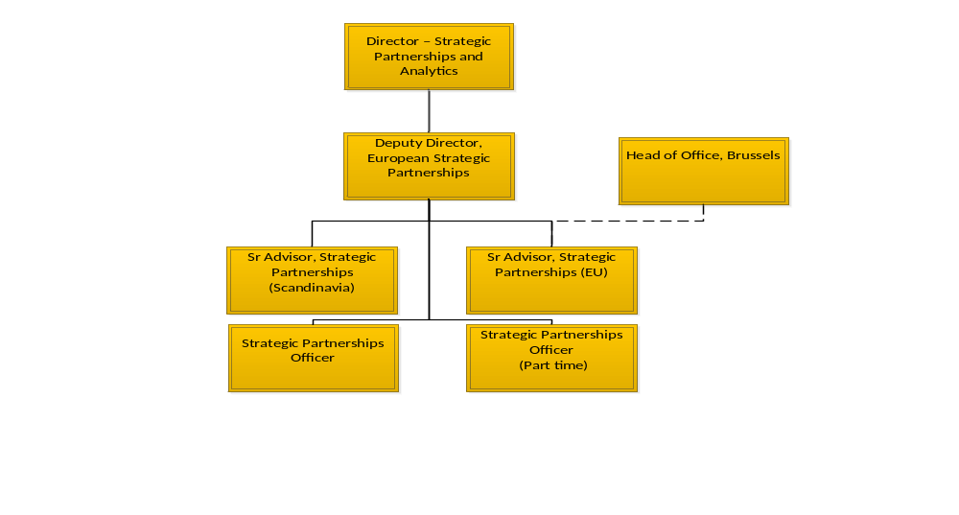
Purpose of the Role

The newly formed Strategic Partnerships and Analytics Team will bring together two existing units: the Donor Relations and Analytics Team within the Awards Management Unit (AMU) and the European Strategic Partnerships Team (ESPT) within IRC-UK. The merger will create a single team with responsibility for both relationship management of IRC’s key institutional donors, and owning and managing AMU information systems and data analytics.

The Strategic Partnerships Officer ensures that the Strategic Partnerships and Analytics team and its stakeholders have access to accurate, relevant and timely information on IRC’s donor relationships, pipeline and portfolio, including information from donors where English is not the primary language.
Scope and Authority

Authority:
- Raise the profile of the team and its work internally through mechanisms such as inductions, Intranet, internal communications and internal meetings.

Responsibility for Resources:
- This role will not have budget or staff management responsibilities

Key Working Relationships

- Reports to the Deputy Director, Strategic Partnerships - Europe
- Works closely with the Senior Advisors, Strategic Partnerships
- Provides support on specific projects to the Director, Strategic Partnerships and Analytics
- Close co-ordination with the other Departments including AMU, GPP’s Strategic Growth Team, Policy and Practice and AMU Senior Management Team
- Supports other teams to understand relationship management (structures and processes) within the global organisation.

Key Accountabilities and Major Responsibilities
Strategic Donor Research and Analysis (35% of time)

- Source, gather and maintain high-quality and up-to-date information on trends relating to IRC donors and ensure that new policies, funding trends, preferred partners and political/personnel changes are identified quickly and the correct IRC staff notified.
- Conduct analysis to understand trends within IRC’s programme development and implementation, such as review of trends in successful/unsuccessful proposals and recommendations to improve success rates.
- Conduct research in to prospective new donors or financing instruments, coordinating efforts with AMU Programme Development, GPP’s Strategic Growth Team and the IRC-UK Senior Management Team.

Information Management and Coordination (35% of time)

- Maintain the Strategic Partnerships Team Donor RescueNet Profiles and other key documents/products, ensuring that all IRC staff have access to concise, relevant and timely information on these key donors and IRC’s relationship with them.
- Maintain and develop systems and tools to support knowledge management and information sharing including CRM and Intranet.
- Maintain team calendar and overall work plan for the team.
- Assist information sharing and collaboration on target donor engagement across teams, including Policy, Advocacy and Communications, Technical Units, AMU and other colleagues.
- Coordinate monthly internal meetings and quarterly review meetings for target donors.
- Support the design and successful delivery of an Annual Donor Meeting.

Internal and external communications (30% of time)

- Prepare products to support improved donor engagement for use by AMU and other IRC colleagues, including country offices.
- Prepare research for reports, briefings, donor profiles, presentations and other materials for internal and external use.
- Identify opportunities to increase IRC’s profile in target countries and ensure appropriate IRC representation at relevant meetings.
- Develop and maintain internal communications content and systems.
- Contribute to external communications content to increase IRC’s profile with donors, partners, and other key stakeholders in target countries.

In addition, work flexibly within the Strategic Partnerships and Analytics Team to support other areas of work.

PERSON SPECIFICATION
Essential

Skills, Knowledge and Qualifications:

- Bachelor’s Degree preferably in a related field such as International Development, Economic Development, Geography, or Social Anthropology, or experience leading to equivalent knowledge
- Proven interest & commitment to humanitarian and development issues
- Excellent organisational skills: the ability to work independently & productively in a fast-paced environment and ability to effectively see projects through from start to finish
- Proven research, writing and editing skills: the ability to draft and edit reports, memos, and letters
- Excellent interpersonal and communication skills: the ability to successfully and effectively liaise with a variety of people in a multi-cultural and multi-site environment; Must be a team player
- Flexible work attitude, proactive and demonstrated creativity: the ability to work productively in a team environment and the ability to problem solve creatively with minimal guidance
- Fluency in English, both verbal and written is required
- Excellent Computer skills: MS Word, Excel, PowerPoint and CRM/database.
- Demonstrable experience of working with institutional donors.
- Proven ability to work supportively and successfully with virtual teams.

Desirable:
- Fluent in German or French (ability to have external meetings/discussions in language, including technical dialogue; ability to understand and summarise donor documents, media, etc. into English).
- Experience in building and managing institutional/public donor relations and representation of the organisation to diverse audiences.
- Experience of working with European Institutional donors including coordinating and writing concept notes, proposals and reports.
- Working with an international development, humanitarian or large charitable organisation is highly desirable.

To Apply

Please send a CV (two pages maximum) and cover page (two pages maximum) to: applications@rescue-uk.org

Please state clearly in your cover letter:
- Your reasons for applying
- How you meet the person specification, skills and experience specified in the job description
- Where you saw the job advertised
- Current salary

The deadline for applications is 10:00am UK time on Monday 4th October 2017.

Interviews will be held on Tuesday 11th October 2017 & Wednesday 12th October 2017.

In order to minimise administrative costs, IRC-UK will only contact short-listed candidates.

Candidates must have the right to work in the UK.

IRC-UK strives to be an equal opportunities employer. IRC-UK is committed to equality of opportunity and to non-discrimination for all job applicants and employees, and we seek to ensure we achieve diversity in our workforce regardless of gender, race, religious beliefs, nationality, ethnic/national origin, sexual orientation, age, marital status or disability.

