International Rescue Committee, Inc.

Request for Proposal for:
Global Partnership and Philanthropy Technology Strategy Consulting

Issued: November 28, 2017

Contents

I. Summary 3
II. IRC Overview 4
III. Technology Overview 5
IV. Guiding Principles 10
V. Strategy Team 10
VI. Specific Desired Services 11
Inception 11
Part 1: GPP Strategy 11
Part 2: Raiser’s Edge Database Conversion to Salesforce 14
Part 3: Public Donor Systems Assessment 15
VII. Deliverables 16
Part 1: GPP Strategy 16
Part 2: Raiser’s Edge Database Conversion to Salesforce 16
Part 3: Public Donor Systems Assessment 16
VIII. Proposal requirements 17
IX. Evaluation of Proposals 17
X. Proposal format 17
XI. Other terms and conditions 19

Summary

This RFP is issued by the International Rescue Committee in order to solicit consulting support for three areas of work associated with systems supporting the Global Partnerships & Philanthropy (GPP) and Award Management (AMU) Departments.
The three areas of work covered in this RFP include:
- Lead consulting and analysis to develop the GPP technology strategy
- Direct analysis, configuration, data conversion, and implementation to support the conversion of a Raiser’s Edge donor database used by the IRC UK office into Salesforce (in alignment with the overall Salesforce strategy as part of #1)
- Consulting assessment and recommendations of platforms for public donor management

Planned Timetable
Issue RFP | November 28, 2017
Intent to Bid Received from Supplier | December 1, 2017
Questions from Supplier due date | November 29 – December 4, 2017
Deadline for IRC reply to Questions | December 6, 2017
****Deadline for Vendor Bid Submission**** | Midnight EST December 8, 2017
Vendor Meetings | December 11-15, 2017
Award of Contracts | January 4, 2018
SOW Discussions | January 4-8, 2018
Contract start | TBD

Intent to Bid
Kindly complete the attached Intent to Bid document and return to Sandy.Pather@rescue.org and Navin.Samtani@rescue.org on or before December 1, 2017.

Vendor Questions
Kindly submit questions to Sandy.Pather@rescue.org and Navin.Samtani@rescue.org on or before December 4, 2017.

Bid Submission
All bids to be submitted to GSC-RFPSubmissions@rescue.org on or before midnight USA EST December 8, 2017.

IRC Overview

IRC Background:
Founded in 1933 at the suggestion of Albert Einstein, the International Rescue Committee (IRC) responds to the world’s worst humanitarian crises and helps people whose lives and livelihoods are shattered by conflict and disaster to survive, recover, and gain control of their future.

Working in over 40 countries, the IRC is a leader in humanitarian relief - bringing sustained support to regions torn apart by conflict and disaster. In addition to our work overseas, the IRC also has 29 U.S. resettlement offices that help newly arrived refugees by providing immediate services. The IRC advocates on behalf of the displaced by addressing the root causes of conflict and standing up for the world’s most vulnerable populations. The IRC's strategy centers on its ambition to continue to improve the scale and effectiveness of IRC programs worldwide with evidence of what works best to impact people’s lives in conflict and fragile settings.

Global Partnerships & Philanthropy
IRC's GPP department is responsible for the global delivery of the IRC’s private sector financial resources, and plays an important strategic role in the creation of its brand, awareness and advocacy goals. GPP comprises of teams delivering marketing, account management, leadership gifts, board liaison, and corporate/foundation partnerships to support this work. Primarily these teams are located in the USA with a sister operation in the UK, but GPP’s strategic vision is to diversify IRC’s geographic footprint and funding sources, both by type and by market. GPP partners closely in its private sector engagement work with the IRC’s Communications team, which provides media relations, content, and website platforms and digital expertise. GPP also works closely with the Awards Management Unit (AMU), which comprises teams that support IRC’s work with public/statutory funders, including business development, donor relations and research, compliance and policy, grants management, and learning and training.

It is important to note that the IRC is currently evolving its global fundraising approach and practices, and implementing delivery of new strategic plans. The following high-level goals have been established:

- Build relationships with current and new supporters (private & public sector) and grow private sector funding from $170 million in 2017 to > $300 million (est. 40% of total IRC funding) by 2020
- Reduce risk and increase sustainability by diversifying future funding streams and expanding into new geographic and structural markets
- Increase global IRC brand awareness, profile and donor base
- Respond rapidly to fundraise for humanitarian emergencies

Technology Overview

Technology Background and Current Systems State
IRC staff have made substantial progress to develop new and simplified philanthropy systems, but staff nonetheless currently experience a diverse set of problems and pain points from current systems in their operational and analytical work. These challenges create a negative drag on implementing business goals that can be summarized as follows:
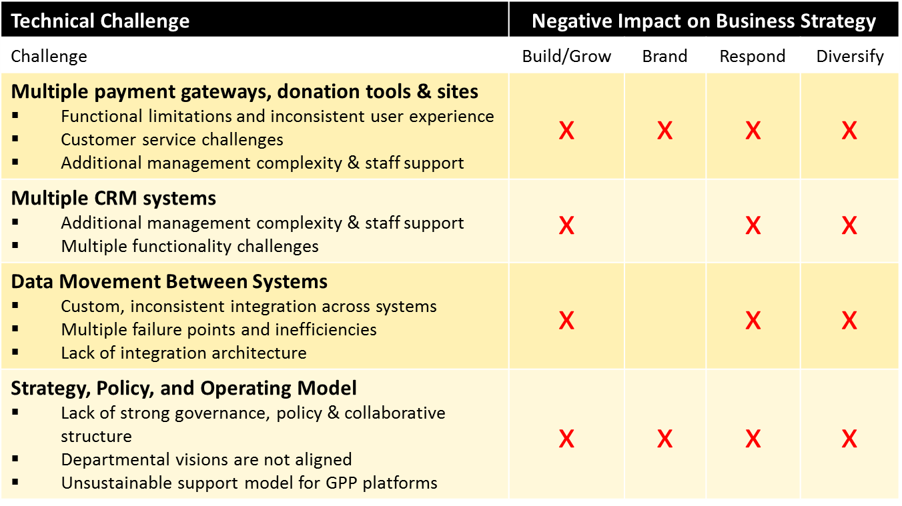
Figure 1: Technical Challenges to Business Strategy

IRC has identified that the issues listed are symptoms of process and architectural strain that will get worse with increased volume and thus require IRC to undertake a focused effort in 2018 to develop a 2-3 year systems strategy and architecture.

In 2017, IRC GPP and IT department staff have worked to implement tactical improvements to systems while ensuring alignment on the need for strategic planning to support IRC’s Private Sector Engagement (PSE), IRC Europe, and Awards Management Unit strategies.

- Balance the need to accelerate technology development to take advantage of new global opportunities with the need to create long term adaptable and scalable solutions
- Provide strong and reliable applications and infrastructure to handle rapid scaling of digital investment in current markets
- Provide near-term, scalable donation and payment processing capabilities to support rapid expansion of digital fundraising into new international markets
- Address business pain points and symptoms of architectural strain
- Provide the best possible user experience to IRC donors throughout their interactions with IRC
- Enable multiple types of rapid data and information analysis
- Align with IRC business processes

Strategy Purpose
The following figures illustrates the overall ambition of IRC’s GPP technology strategy. First, the technology strategy should support IRC’s vision of 360º management of constituents.

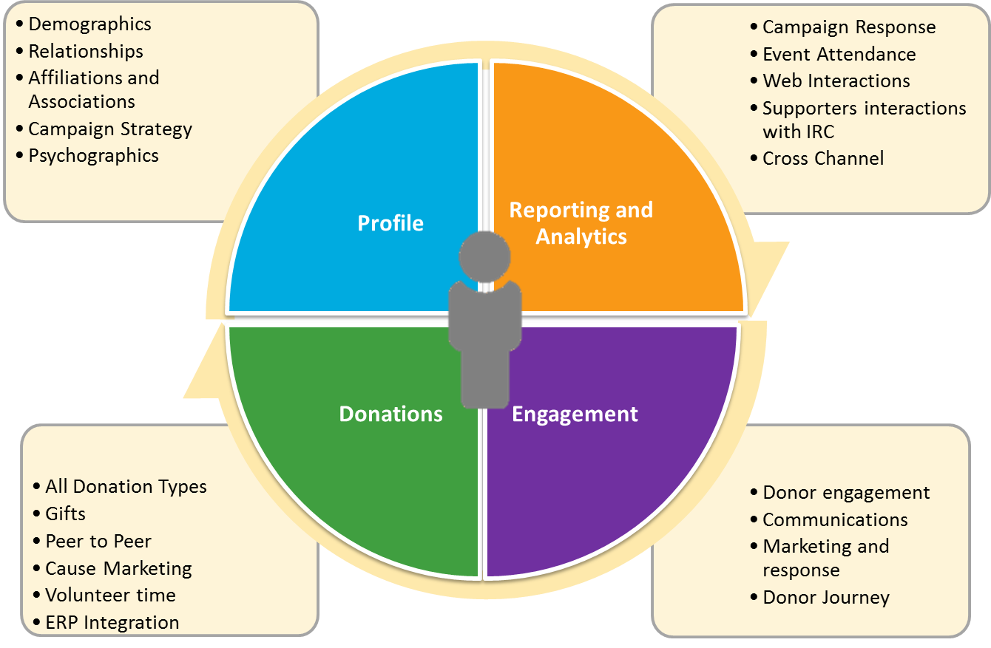
Figure 2: 360º management of IRC constituents

Second, IRC plans to be a “Digital Driven” organization throughout programs and operations with cultural and operational transformations in tow to achieve these goals.

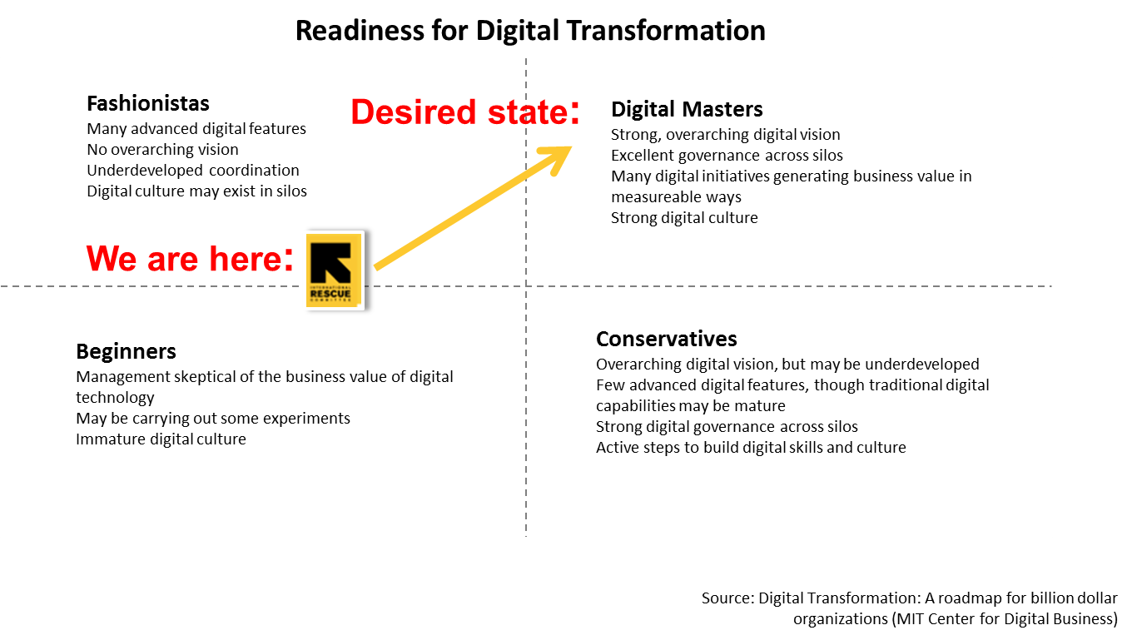
Figure 3: Digital Transformation Roadmap

Based on existing systems state and the balance of tactical and strategic needs, the following technology components have been identified in order to organize existing and future work:

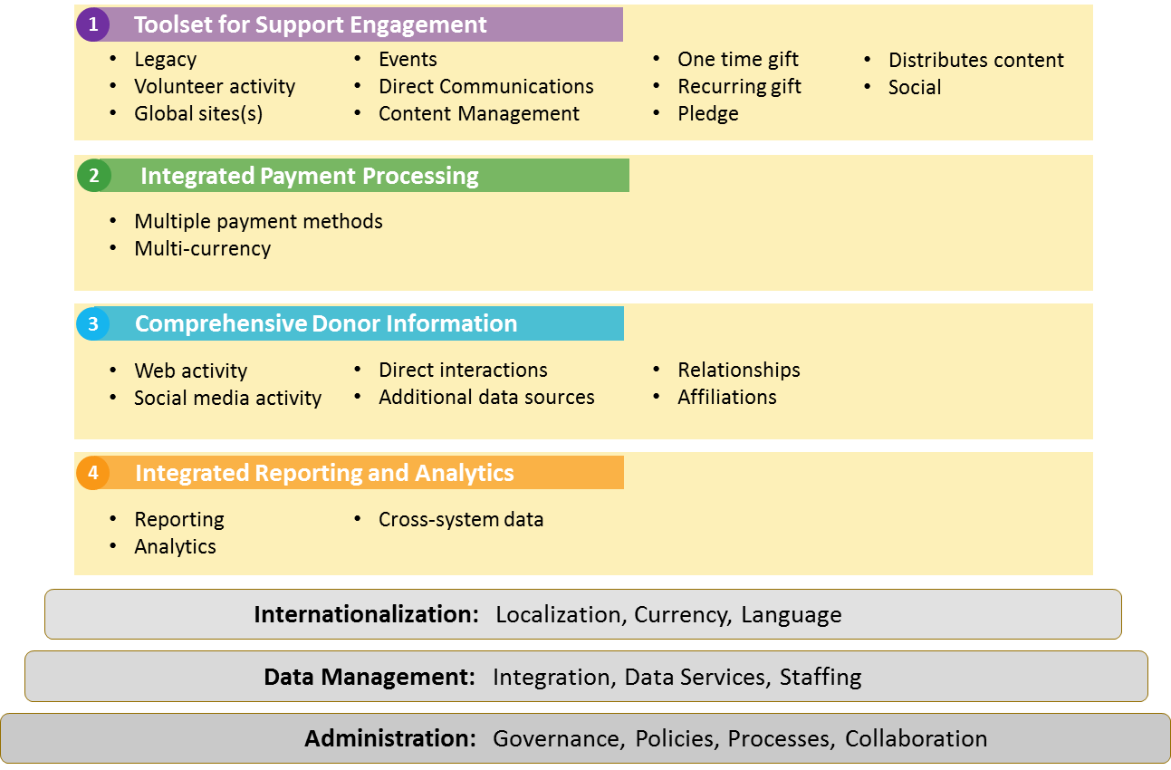
Figure 4: Supporting Business Systems Architecture
The technology strategy will help GPP define its next generation technology portfolio, an initial pre-strategy development version of which is included below:

The GPP 2020 technology strategy will encompass the following areas:

CRM: The CRM strategy development will include our global Salesforce strategy and architecture, business process review for UK CRM and recommendations for a system on Salesforce to manage constituent data for UK and other countries as IRC expands globally. It is important for us to consolidate data in order to provide a 360º view of constituents and also provide for effective donor engagement and communications across channels (email, social etc.). We seek a partner who has deep Salesforce expertise and also understands data and PCI regulations and policies across multiple markets (including Europe, Middle East and Asia) and is able to help design an optimal CRM architecture. CRM strategy should also encompass marketing automation and customer service solutions. We are currently using NGOConnect by roundCorner with Salesforce to manage data hosted in the USA, and Raiser’s Edge to manage donor data in the UK. IBM Silverpop is IRC’s current email marketing solution.

Data analytics: The data analytics strategy development will address the necessary data warehousing, ETL and business intelligence capabilities as they relate to CRM, digital marketing, website, social and other internal and external digital data. The infrastructure must be powerful, integrated, flexible and scalable – and must be closely aligned with wider IRC enterprise infrastructure (i.e. Azure SQL / Power BI). The strategy must address needs for both sophisticated, high-performance analytical tools as well as embedded tools that will democratize data access and interaction, and provide easy visibility to more casual business users. In the US, IRC currently uses an externally supported MYSQL database to provide data warehousing functionality and an integration point with various internal and external data sources. We also currently use Visokio Omniscope to perform a range of functions from job scheduling to ETL and data visualization. IRC staff also utilize a range of other tools (including but not limited to native Salesforce dashboards, Google Analytics, Google Data Studio, SimplyMeasured, Tableau, and Excel) to deliver reporting and data visualization.

Donor facing platforms: The donor facing platform strategy development will encompass IRC’s e-commerce site, Rescue Gifts (https://gifts.rescue.org), the main IRC website (https://www.rescue.org) as well as our donation pages. Donation pages are available for the U.S. (https://help.rescue.org/donate) and also the following countries: U.K., Australia, Canada and New Zealand with an outlook to expand to other countries across Europe and the Middle East in the next quarter. The Donation pages are built on Jackson River’s Springboard platform using Drupal 8 and MongoDB which is integrated with our data warehouse and Salesforce platforms. The Rescue Gifts site has been custom coded by Jackson River in Drupal 8. We seek a single platform (or cohesive platforms) that allows for e-commerce features (tribute gifts / cards) and online donations (one-time and recurring) while being compatible with our current payment processing gateways (Vantiv/Stripe) and Salesforce CRM system. Additionally, multilingual capability, mobile UX rendering and the ability to make customizations easily by our developer staff will be important. Additional considerations include secure transactions / PCI compliance, effective customer support and any non-profit discounts to standard rates/fees.

Payment processing: GPP has performed some work in regards to the technology strategy related to payment processing. This resulted in adoption of Vantiv as the payment processing gateway for the Rescue Gifts site as well as the donation pages for the U.S, Australia, Canada and New Zealand. GPP also has Stripe for setting up short-term / test donation pages that require a quick turnaround time. GPP would like to continue its forward outlook towards integration with next generation gateways/channels such as Apple Pay, Google Wallet, Paypal app, Square Cash, etc. along with which channels may be effective in the geographies where the IRC seeks to expand its fundraising capabilities.

Awards management: While the majority of technology needs to support the Awards Management Unit will be met by IRC’s new ERP system (to be implemented in 2019), our technology strategy should consider areas of intersection – particularly around future CRM needs and potential other pre-award/business development functionality. The IRC uses an internally developed grants management application (OTIS) to support a range of business development and pre-award processes. Currently, AMU does not engage in formal relationship management with government funders, and there is no formal relationship management process for field level relationships. However, some elements of customer relationship management are in place for government donors, and the creation of the AMU’s Donor Relations Team brings the opportunity and expectation of more comprehensive CRM processes.

The high-level desired state can be seen in the following diagram:

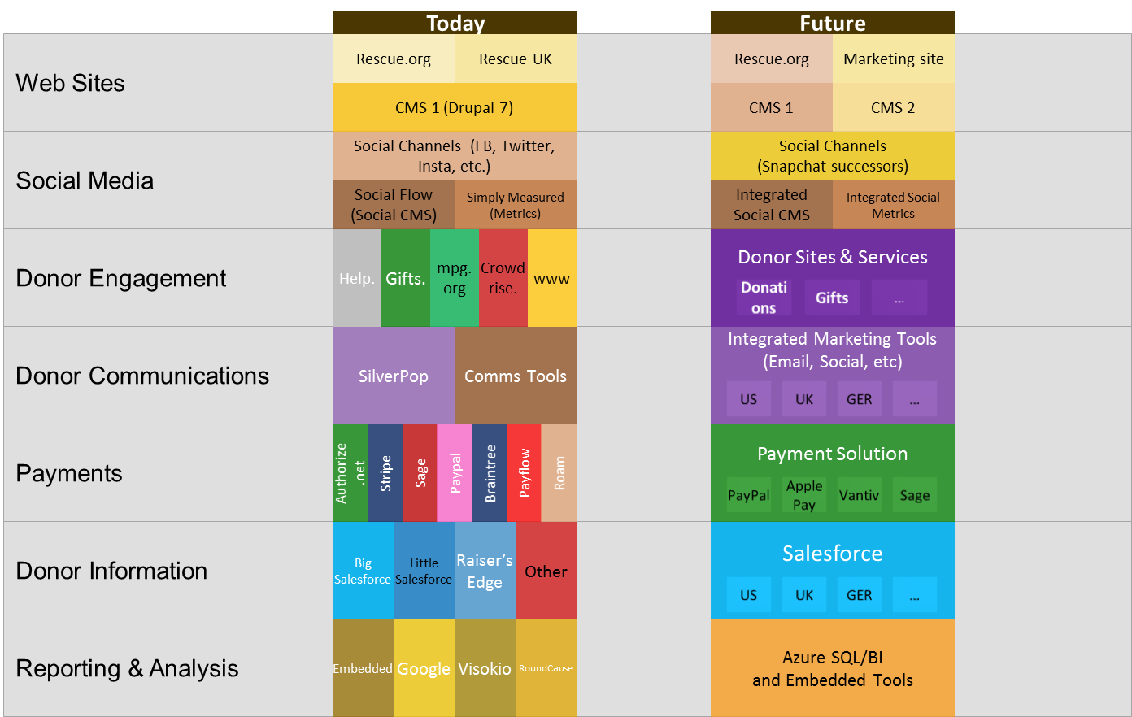
Figure 5: Potential Future Technology portfolio

Guiding Principles

To enable the technology progress to date, the teams have developed the following guiding principles:
- Consistent, high quality, donor-centered user experience design
- Consolidated, constituent, information powering real-time sophisticated analytics
- Localization and policies to prepare for rapid expansion
- Enable improvements to the donor journey
- Automated, accurate movement of information through integration
- Business driven data and system architecture
- Create policies for the use of existing and new requests for tools and applications
- Sustainable operating model and best use of IRC staff resources to support a modern GPP architecture
- Data stewardship, governance and protection
- Reliable, flexible and easy to maintain cloud solutions with nimble, agile deployment of new features

Strategy Team

The GPP technology strategy team currently consists of:
- Deputy Vice President, Data & Analytics
- Director, Applications
- Data Architect
- Director, Digital Technology
- Project Manager

Extended core team members will likely include:
- Senior Director, Digital Platforms
- Director, Global Opportunities
- Director, Analytics
- Director, Database and Gift Management
- Director, Business Relationship Management, IT
- Senior Director, Global Infrastructure, IT

Governance is provided through a steering process and resource review board. In addition, recurring guidance will be provided by:
- Senior Vice President, GPP
- Chief Information Officer
- Vice President, Strategic Growth, GPP

Specific Desired Services

This Request for Proposal (RFP) invites consultants and agencies to submit proposals for providing the following services to the International Rescue Committee Strategic Growth team, starting in December 2017. It is anticipated that services outlined under Parts 1 and 3 below will be delivered within a period of approximately 6 months. Some phases of Part 2 may extend beyond the 6-month timeframe depending on final business requirements.

The desired services are divided into three parts. Vendors can choose not to respond to all parts, however preference will be given to vendors who offer services covering all areas of the RFP.

Inception
IRC recognizes that all services will begin with an inception phase in order to:
- Review and adjust existing project plans
- Confirm deliverables and metrics
- Confirm team structure and charter
- Confirm governance
- Change management planning (communications, training, etc.) using an ADKAR model if necessary

Part 1: GPP Strategy
IRC plans to build on progress in 2017 and develop a 2-3 year technology strategy to support GPP’s 2020 business goals. Note that IRC is not contemplating a move away from Salesforce and expect the strategy to be Salesforce-centric. While this RFP notes 4 streams or areas of technology planning to date, the strategy will necessarily encompass review of support for marketing, social media, digital media, physical mail, and other business strategies as they contribute to the 360º management of donors.
The following sections outline IRC priorities for strategy development based on existing knowledge: IRC plans to engage with the selected vendor during an inception phase to ensure alignment on deliverables, scope, and methodologies.
In the GPP Strategy area, IRC expects to follow approximately the following stages, with a particular focus on donor journeys as the anchoring point of technology to business strategy.
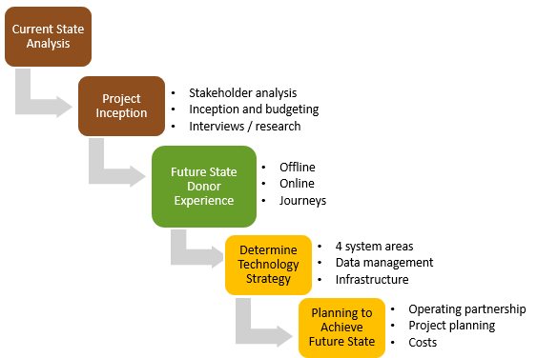
Figure 6: Proposed strategy development approach

Specific vendor activities will include:

- Discovery and analysis as applicable
  - Perform interviews / workshops to develop stakeholder input
  - Business process analysis – note IRC does not expect full business process review and design as part of the strategy development but the strategy should include analysis and to-be design of key supporting business processes and enumeration of gaps and opportunities where IRC should further investigate changes or adopting industry best practices
  - Relevant rules and regulations including data privacy generally, PCI and EU General Data Privacy Regulations
  - Review of key data elements and data models
  - Functional, reporting, and data requirements and gaps
  - Review of and recommendations as to Salesforce add-ins, NPSP, and NGOC
  - External environment analysis
    - NGO sector
    - Nonprofit sector
    - For-profit
- Strategy
  - Technology strategy, approaches, and recommendations for IRC 2020 GPP systems
  - Recommended roadmap
  - Implementation approach, phasing, and timeframe
  - Cost and ROI projections
  - Security and compliance
- Operating Model
  - Internal and partner staffing recommendations
  - Staffing structure recommendations
  - Business process changes

The following section describes four anticipated streams of work and high-level goals to address components of the GPP technology strategy. It is not an exhaustive list but illustrative of IRC’s current expectations. Additional components may be included during the inception phase. Note, vendors should base their cost proposals on these components but list any suggested additions as separate line items.
- Donor journeys, touch-points and overall donor-facing tool options
IRC seeks to provide a best-in-class connected experience for donors across the range of potential touch points, including digital, physical mail, peer fundraising, volunteering, travel, social media, advocacy, gifts, physical delivery, events, campaigns, estate planning, etc. The GPP strategy should develop options and guidance for creating a connected and planned donor experience across a range of interactions. The donor journeys will be the anchor point for development of supporting technology strategies.
  - Identify data and PCI rules, regulations and policies for the international markets the IRC seeks to expand to (UK, Germany/Europe, Middle East, Australia and New Zealand)
  - Recommendations for a single platform (or cohesive platforms) that allows for 360º donor management, including e-commerce features (tribute gifts / cards) and online donations (one-time and recurring) while being compatible with our current payment processing gateways (Vantiv/Stripe) and Salesforce CRM system.
  - Multilingual and localization capability, mobile UX rendering
  - Review operational challenges and gaps and recommend systems/business process change(s)
- Customer relationship management (CRM) systems
Review existing state and develop implementation guidelines, policies, and strategies to meet IRC’s needs for rapid scalability into new markets in response to humanitarian needs
  - Recommend Salesforce CRM architecture as to one instance vs. multiple instances and decision criteria
  - Define security structure for Salesforce
  - Identify integration points for multiple Salesforce instances (if necessary) and external systems
  - Assess viability of potential Salesforce apps to deliver functionality vs. custom development
- Data analytics and reporting
IRC seeks to develop cross-functional multi-domain analytics that will include all donor touch-points (CRM, Clickstream, campaign interactions, etc.) and other IRC financial and operational data sets (ERP, Awards Management, HR, etc.)
  - Identify GPP business data needs and gaps
  - Identify an approach to the collection, integration, warehousing, analysis, reporting, and delivery of GPP data needed to serve GPP business purposes.
  - Ensure GPP approach is aligned with IRC’s overall data and systems strategies
- Payment Processing
IRC uses several payment processing platforms and has recently identified preferred future platforms (Vantiv / Stripe). The strategy will further test those platforms against future scenarios and expand the planning and guidance for rapid implementation into new markets.
  - Identify data and PCI rules, regulations and policies for the international markets the IRC seeks to expand to (UK, Germany/Europe, Middle East, Australia and New Zealand)
  - Provide recommendations for integration with next generation gateways/channels such as Apple Pay, Google Wallet, Paypal app, Square Cash, etc. along with which channels may be effective in the geographies where the IRC seeks to expand its fundraising capabilities

Part 2: Raiser’s Edge Database Conversion to Salesforce
IRC’s GPP UK staff currently use a Blackbaud Raiser’s Edge platform to manage their donor relations. IRC wishes to convert the database to use the same Salesforce platform in use in the US.
Activities and plans should include:
- Discovery and analysis
  - Stakeholder interviews and workshops
  - Project success and quality metrics
  - Perform interviews / workshops to develop stakeholder input
  - Business process analysis
  - Functional, reporting, and data requirements and gaps
  - Relevant rules and regulations including data privacy generally, PCI and EU General Data Privacy Regulations
- Process, security, system, and data functional / architecture design recommendations
  - Design / recommend any necessary changes to business processes
  - Design / recommend any necessary changes to information security policies or processes
  - Design / recommend any necessary changes to US Salesforce configurations, data models, or analytical structures
  - Design / recommend any necessary modifications to system functionality
  - Analysis findings will be documented for stage gate approval before continuing.
- Configuration and Data
  - Configuration of Salesforce as necessary
  - Data extraction, conversion, preparation, and load into Salesforce
- Testing
  - Generate test plans
  - Data testing
  - Functional testing
  - Regression testing
- Go-live preparation
  - Testing Review
  - Documentation
  - Training
  - Planning
- Post go-live hyper care
- Final report on outcomes and metrics achieved
Note: Activities involved in this scope of work may involve travel to the UK. Alternatively, bidders are requested to specify if they have resources in the UK that may be readily available to support these activities in lieu of travel to the UK by US-based resources.

Part 3: Public Donor Systems Assessment
For the last 8 years, IRC has used a custom solution for the management of large public donors and awards throughout their lifecycle – the Opportunity Tracking Information System (OTIS). Currently, IRC is implementing Microsoft Dynamics 365 (D365) which will implement financial tracking of awards but cover areas of the award lifecycle including:
- Public donor relationship management
- Opportunity development
- Donor reporting
- Indicator collection and aggregation and management
- Document management
- Time management
- Unified functional award reporting
- Work planning and logframes
- Donor rule compliance

In light of D365, IRC seeks to assess the utility of Salesforce for public donor CRM and award management.

IRC anticipates the following activity in support this part of the RFP:
- Discovery and analysis as applicable
  - Perform interviews / workshops to develop stakeholder input
  - High-level business process analysis – note IRC does not expect full business process review and design as part of the strategy development but the strategy should include analysis and enumeration of gaps and opportunities where IRC should further investigate changes or adopt industry best practices
  - Review of key data elements and data models
  - Functional, reporting, and data requirements and gaps
  - Review of Salesforce marketplace and applicable options
  - External environment analysis
    - NGO sector
    - Nonprofit sector
- Strategy
  - Develop a high level assessment of IRC’s options for moving public donor management into Salesforce
    - Pros
    - Cons
    - Costs
    - Timelines
  - Develop a high level assessment of IRC’s options for moving whole lifecycle award management into Salesforce
    - Pros
    - Cons
    - Costs
    - Timelines

Deliverables

The desired outcomes/deliverables of this initiative are.

Part 1: GPP Strategy

- Description of IRC’s donor growth and business strategies and their technology implications
- Overall GPP 2020 Technology Strategy and Roadmap
  - Analysis of sequencing options and tradeoffs
  - Analysis of near-future donor management trends and implications for IRC
  - Cost and ROI projections
  - Description of information security and compliance needs and approaches Architecture Diagrams
  - Data Models
  - To-be Business process diagrams and Gap Analyses
- Operating Model and Sample Budgets

Part 2: Raiser’s Edge Database Conversion to Salesforce

- Stakeholder analysis
- Functional and technical requirement documents
- Data model mapping and gap analysis
- Data conversion maps
- Data conversion test plans
- Operating model including support plan
- Successful conversion of data from UK raiser’s edge to Salesforce donor database
- Training plan for UK CRM staff
- Business process analysis and gap list that delineates change management plan for UK staff to successfully transition to use of Salesforce
- Go-live planning and execution
- Hyper-care post go-live support plan

Part 3: Public Donor Systems Assessment

- Analysis of IRC’s existing and desired approach to public donor management and award management
- Technology options, and recommendations desired approach to public donor management and award management in light of IRC’s current and future applications roadmap
  - Pros and cons
  - Cost and ROI projections
- Architecture Option Diagrams
- Data Models Options

Proposal requirements

Proposal Inclusions:

Please note that the finalist will need to pass a conflict of interest review that is standard for all International Rescue Committee partners.

Please include the following in your proposal:

- Experience and references including names and CVs of the potential team that would work on the International Rescue Committee account.
- Current client roster and length of time each client worked with consultant. This list should include all current relevant clients.
- Describe your view of the ideal partnership with a client and how you would structure the account.

Evaluation of Proposals

Proposals will be scored using the following technical criteria. Proposals should address each evaluation criteria.
- Technical Criteria: Includes the bidder’s understanding and experience implementing requirements similar to IRC requirements across CRM, data analytics, donor facing platforms, payment processing gateways and awards management. Specifically, in regards to CRM, data regulations and compliance for UK, Germany and rest of Europe, Middle East, Australia and New Zealand as well as experience implementing Salesforce architecture across the globe.
- Management Criteria: Includes the bidder’s experience on similar projects, bidder’s performance on similar projects, bidder’s available facilities and resources for the project and the bidder’s plan for management and control of the project. In particular bidder’s experience and past performance related to non-profit sector will be crucial.
- Cost Criteria: Is the cost within any pre-determined price range, such as cost estimates from a market analysis? In most cases, cost is evaluated using value for money unless otherwise directed by donor requirements. While bidders may submit individual bids for the three components of the requested scope of work, preference will be given to vendors that bid for all three components from a cost perspective.

Proposal format

Please submit proposals as two separate documents in Microsoft Word or Adobe PDF files formats as follows:

- Cost Proposal
Please provide a detailed schedule of fees and rate cards that outlines all components of your services as any hourly or additional costs. Bidders are encouraged to provide fixed-fee options based on existing methodologies and experience, time and materials options, or a combination of both if applicable.

- Service Proposal (no more than 50 pages in total)
Please describe your approach and understanding of the services requested by IRC, relevant experience in delivering similar services, suggested timeframes and progression, understanding and experience with Salesforce, and existing strategic planning frameworks.

In addition, please include:

- Name, address, telephone number and email address for principal contact.
- A brief outline of your organization and services offered, including:
- Full legal name, jurisdiction of organization or incorporation and address of the company
- Year business was established
- Relevant services offered, certifications, partnerships and depth of experience in each service
- Name and professional qualifications of personnel who would provide the services. IRC plans to begin the engagement rapidly and will expect to meet with specific consultants who will provide the services.
- At least two relevant reference clients (names, addresses, phone numbers and email addresses) that IRC can contact such as international non-profits, large (annual budget > $500m) non-profits, and humanitarian relief agencies.
- Describe your view of the ideal relationship and methodologies for engagement of business stakeholders, core cross-functional GPP strategy team, and subject matter experts.

CONTACT FOR BID INQUIRIES
All inquiries concerning this solicitation shall be addressed to the following Designated Contacts:

Sandy Pather - Indirect Procurement
Sandy.Pather@rescue.org

Please email an electronic version of your response (via e-mail), including all supporting documentation, and direct questions about the RFP to each of the designated contacts.

All questions should be submitted in writing (via email) citing the particular bid section, question and/or paragraph number. Bidders should note that all clarifications and exceptions are to be resolved prior to the submission of a bid.

Only questions received during the Question and Answer period (as outlined in the RFP
Calendar) will be addressed. No telephone questions will be answered. Official answers to the questions will be shared with all respondents on the date indicated in the RFP Calendar.

RFP CALENDAR/TIMELINE

- RFP published: November 28, 2017
- Notification of intent to respond: December 1, 2017
- Questions and Answers period: November 29, 2017 – December 6, 2017 (All questions must be submitted by 5pm December 4, 2017 to merit a response)
- RFP responses due: December 8, 2017
- Vendor meetings week of: December 11, 2017 – December 15, 2017
  - IRC plans to meet 2 vendor finalists for full day meetings including participation by high-level vendor staff leaders such as architects, lead consultants, etc.
- Vendor selected and notified by: January 4, 2018

Other terms and conditions

INSURANCE
Prior to the commencement of the work to be performed by the successful Bidder, the Bidder shall file with IRC Certificates of Insurance evidencing compliance with all requirements contained in this RFP. Acceptance and/or approval by IRC does not and shall not be construed to relieve Bidder of any obligations, responsibilities or liabilities under the contract awarded by this RFP.

All insurance required by the RFP shall be obtained at the sole cost of the bidder and shall be maintained with insurance carriers licensed to do business in New York State and acceptable to the IRC, shall be primary and non-contributing to any insurance or self-insurance obtained by the IRC, shall be endorsed to provide written notice be given to the IRC at least thirty days (30) prior to the cancellation, non-renewal or material alteration of such policies, which notice, evidenced by return receipt of U.S. Certified Mail, and shall be sent in accordance to the provisions of this agreement and shall name the IRC, its officers, agents and employees as additional insurers hereunder.

The Bidder shall be solely responsible for the payment of all deductibles and self-insured retentions to which such policies are subject. Deductibles and self-insured retentions must be approved by IRC. Such approval shall not be unreasonably withheld.

If IRC allows subcontracting, the Bidder shall require that any subcontractors hired carry insurance with the same limits and provisions provided herein.

The Bidder shall cause all insurance to be in full force and effect as of the commencement date of the contract awarded as a result of this RFP, and to remain in full force and effect throughout the term of the contract and as further required by this RFP. The Bidder shall not take any action, or omit to take any action that would suspend or invalidate any of the required coverage during the period of time such coverage are required to be in effect.

Not less than thirty (30) days prior to the expiration date or renewal date, the Bidder shall supply
IRC with updated replacement Certificates of Insurance, and amendatory endorsements.

The Bidder, throughout the term of the contract, or as otherwise required by this RFP, shall obtain and maintain in full force and effect, the following insurance with limits not less than those described below and as required by the terms of this RFP, or as required by law, whichever is greater (limits may be provided through a combination of primary and umbrella/excess policies):

- Commercial General Liability Insurance with a limit of not less than $1,000,000 each occurrence, with a limit of not less than $1,000,000 aggregate. Such liability shall provide equivalent coverage and shall cover liability arising from premises operations, independent contractors, products-completed operations, broad form property damage, personal & advertising injury, cross liability coverage, liability assumed in a contract (including the tort liability of another assumed in a contract) and explosion, collapse & underground coverage.

- Workers Compensation, Employers Liability, and Disability Benefits as required by New
York State.

- Comprehensive Business Automobile Liability Insurance with a limit of not less than
$1,000,000 each accident. Such insurance shall cover liability arising out of any automobile including owned, leased, hired and non-owned automobiles.

- Professional Liability Insurance, covering actual or alleged negligent acts, errors or omissions committed by the Contractor, its agents or employees, arising out of the work performed under this Agreement. The policy coverage shall extend to include bodily injury and property damage from negligent performance of professional services and personal injury liability coverage for claims arising out of performance of services. The policy shall have limits of liability of not less than $1,000,000 each occurrence, with a limit not less than $1,000,000 aggregate. The Contractor shall be responsible for payment of all claim expenses and loss payments with the deductible.

Waiver of Subrogation. Bidder shall cause to be included in each of its policies insuring against loss, damage or destruction by fire or other insured casualty a waiver of the insurer’s right of subrogation against IRC, or, if such waiver is unobtainable (i) an express agreement that such policy shall not be invalidated if Bidder waives or has waived before the casualty, the right of recovery against IRC or (ii) any other form of permission for the release of IRC.

Awarded Bidder shall furnish evidence of all policies to IRC, before any work is started.
Certificates of Insurance may be supplied as evidence of such aforementioned policies; however, if requested by the Agency, the Bidder shall deliver to IRC within forty-five (45) days of the request a copy of such policies, certified by the insurance carrier as being true and complete. If a Certificate of Insurance is submitted it must: (1) be signed by an authorized representative of the insurance carrier or producer and notarized; (2) disclose any deductible, self-insured retention, aggregate limit or any exclusions to the policy that materially change the coverage; (3) indicate the Additional Insurers and Named Insurers as required herein; (4) reference the Agreement by number on the face of the certificate; and (5) expressly reference the inclusion of all required endorsements.

If, at any time during the term of the resulting contract, insurance as required is not in effect, or proof thereof is not provided to IRC, IRC shall have the option to: (i) direct the Contractor to suspend work with no additional cost or extension of time due on account thereof, or (ii) treat such failure as a breach in contract.

The successful Bidder will indemnify IRC against any and all liability which may be assessed against it as a result of the actions, activities, neglect, or malpractice of the successful Bidder, its officers, employees’ agents, subcontractors or corresponding attorneys relating to its performance of the functions required. Specifically, the successful Bidder will provide a malpractice policy and a public liability policy to the benefit of IRC in the amount of $2,000,000 each to insure against liability due to harassment, defamation, personal injury, violation of privacy

IRC SMALL & DISADVANTAGED BUSINESS GUIDELINE
It is the policy of IRC to encourage the greatest possible participation of disadvantaged businesses as bidders. IRC has established goals for each of the following disadvantaged business categories:

- Small Business (SB)
- Small Disadvantaged (SDB) including Alaska Native Corporations and Indian Tribes,
- Women-owned and Economically Disadvantaged Women-Owned (WOSB)
- Historically Underutilized Business Zone (HUBZone)
- Veteran Owned Small Business (VOSB)
- Service-Disabled Veteran-Owned (SDVOSB) Small Businesses and “Other than Small Business”

For purposes of this bid response, bidders should indicate their eligibility for any of the above-listed categories. If chosen as a finalist, you will be required to provide your registration number as well as additional information.

WITHDRAWAL OF RFP
Proposals may be withdrawn before the RFP submittal deadline by submitting a written request to the Contact Person. Re-submittal before the RFP submittal deadline can be made; however, they may not be re-submitted after the deadline.

RFP COSTS
All costs incurred in the preparation and presentation of proposals to the RFP shall be completely absorbed by the responding party to the RFP. All documents submitted as part of the RFP will become property of the IRC. Requests for specific material to be returned will be considered. Any material submitted that is confidential must be clearly marked as such.

AWARD BASIS
At the option of the IRC, finalists for the Agent designation may be selected for a final round of negotiations; however, applicants are encouraged to present their best offers with their initial submission. IRC reserves the right to accept or reject any and all proposals, to waive any irregularities in any proposal process, and to make an award of contract in any manner in which IRC, acting in the sole and exclusive exercise of its discretion, deems to be in IRC’s best interest.

CONTRACTUAL DEVELOPMENT
Once an applicant is approved as the exclusive Agent, the successful respondent will enter into a contract with the IRC. Contract discussion and negotiation will follow the award selection. Bidders must be amenable to inclusion, in a contract, of any information provided whether herein or in response to this RFP, or developed subsequently during the selection process.

CONTRACT TERMS
Firms that are selected as the exclusive Agent are eligible to enter into a service contract. The IRC may terminate the contract upon written notice to the Agent of not less than thirty (30) days.

EQUAL OPPORTUNITY
The IRC emphasizes that all respondents will receive full consideration without regard to race, color, religion, sex, national origin, sex, disability, age or sexual orientation. Minority and women-owned firms are especially encouraged to respond to this RFP.

LIMITATIONS
The IRC, reserves the right to reject any and all Proposals and to waive any informality in the solicitation process. Total proposal length excluding cover letter, details of professionals who will provide services, and contact information of client references, should not exceed 12 pages.

