Executive Summary

While wealthier nations begin to offer already fully vaccinated populations a third dose, many countries lag far behind – and many vulnerable populations are struggling to even obtain their first. The WHO has reported that more than 80 percent of vaccines have gone to high- and upper-middle income countries, even though they comprise less than half of the world’s population. In the 20 countries identified by IRC at greatest risk of a major new – or significantly worsened – humanitarian crisis over 2021, only 2.4 percent of the population has been fully vaccinated, and less than 5 percent of the population has received a single dose of the vaccine. These countries represent 10 percent of the world’s population, but account for 85 percent of those in humanitarian need.
This inequity will stall the global fight against COVID-19 while making the everyday reality for those living in conflict zones and protracted displacement contexts much graver, as COVID-19 will continue to exacerbate existing humanitarian crises, driving poverty, hunger, and insecurity.
To address this challenge, it is no longer enough to merely invest in vaccine production, as many countries simply cannot access adequate supply of vaccines. International attention should now turn to bridging gaps in access and investing in effective and inclusive vaccine distribution plans, while tackling the ongoing socio-economic impacts of the pandemic. Doing so requires more responsive global governance and actions to prioritize vulnerable populations and those hardest to reach. It also requires urgent action to mitigate the secondary impacts of the pandemic – on food insecurity and the rights of women and children – as exacerbated by conflict and climate.
To bridge gaps in global response and center vulnerable populations in fragile and conflict-affected contexts, we make five central recommendations for global leaders and institutions in this brief:
- Direct more, faster funding to frontline actors.
- Invest in innovative, evidence-based approaches to address the secondary impacts of the pandemic across livelihoods, food insecurity, education, and gender equality.
- Include displaced populations in national recovery plans.
- Prioritize not only vaccine production, but country preparedness and planning, to ensure countries reach displaced and remote populations.
- Reform the humanitarian financing system at large.

Making the COVID-19 response more equitable, inclusive, and accessible

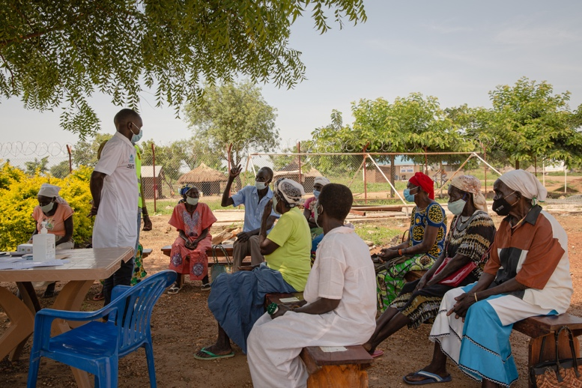
One of the principal barriers to ending the pandemic remains access to vaccines. Gaps in access manifest themselves in countries’ responses, as those with widespread access resume a semblance of normalcy, while those with lower supply – or rather, those with supply but excluding whole swaths of their populations – must adapt to a new normal.

COVAX has created a much-needed humanitarian buffer to increase the accessibility of COVID-19 vaccines to high-risk populations who would not otherwise be able to obtain a vaccine. To date, COVAX has shipped more than 255 million doses to 141 participating countries, excluding the 5 percent of the COVAX Facility’s real-time supply expected to be allocated through the buffer by the end of 2021. Still, there remains a need for greater investment in and planning of vaccine delivery and distribution. In many contexts, local, community-based, and international NGOs are best-placed to deliver vaccines to populations that are hard to reach in conflict-affected areas and/or excluded from government vaccination programs. In some contexts, where the government either cannot reach or does not want to reach certain populations, they are already delivering 75 - 80 percent of health services. These organizations have already built rapport and trust with local communities, who may not trust the vaccine itself often due to misinformation flows, international actors, or even their own governments. Underinvestment in technical support for governments to plan distribution and generate demand for the vaccine will prolong the pandemic in these contexts. Frontline responders have the technical expertise to help train health workers and to strengthen supply chains, as well as the relationships needed to build trust and address local concerns driving vaccine hesitancy.
The screening process for the COVID-19 vaccine at Swiga health centre III in Bidi Bidi refugee settlement. Information about the vaccine is shared, medical history is taken, alongside measuring temperatures. Photographer: Esther Mbabazi

Frontline actors need more and faster direct funding to support their response, but institutional barriers remain. On average, two-thirds of humanitarian funding has gone to UN agencies, which then cascade a portion to implementing partners, and 80 percent of funding for the COVID-19 appeal specifically went to UN agencies. However, only 20 percent went directly to frontline NGOs, and funding often took up to 8 months to reach frontline implementing partners. The increasingly protracted nature of conflict and displacement necessitates longer-term, more flexible - unearmarked - funding, to meet skyrocketing humanitarian need. 22 of 25 Humanitarian Response Plans (HRPs) were for crises lasting five or more years. And while humanitarian need increased by 88 percent from 2016 to 2020 - from 125.3 million people in need to 235.4 million - humanitarian assistance only increased by 8.3 percent. Most aid to frontline actors comprises one year or less grants, and as a result, local organizations in particular struggle to manage and sustain operations on a short-term funding model.

Scaling up of innovation for scaling of impact
Greater financial investment alone is not enough; the international community is not adequately addressing the disproportionate impacts of pandemic, the consequent economic crisis, and spillover effects in fragile, conflict, and displacement settings.

In fragile settings, the indirect effects of the pandemic have often eclipsed its direct health impacts. The COVID-19 pandemic and its economic repercussions, together with climate change and ongoing conflict, have exacerbated a global hunger crisis. In 2020, 155 million people across 55 countries were acutely hungry, representing an increase of 20 million since 2019. Acute malnutrition, the most severe and deadly form of malnutrition, is also increasing; estimates suggest an additional 9.3 million children will become acutely malnourished by 2022 because of pandemic-related disruptions in health, food, and economic systems. IRC estimates that an additional 35 million people will be hungry in 2021 as result of the global economic downturn and its associated spillover effects. And yet, in some cases donor budgets have faced deep cuts – of up to 80 percent – to their malnutrition programming.
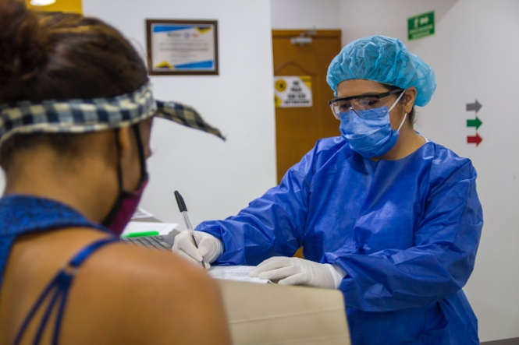
Across these secondary impacts, COVID-19 disproportionately impacted women and girls, disrupting livelihoods as well as access to gender-based violent (GBV) protection services. COVID-19 has rolled back women’s rights and protections, IRC estimates that 20 million girls will likely not return to school in 2021, setting back progress on education by decades. In addition, the UNFPA estimates that 15 million additional cases of GBV will occur for every three months of lockdown due to COVID-19.

To address these setbacks, there are four areas where urgent investments to scale innovative, evidence-based solutions are sorely needed:
A healthcare worker in Cúcuta, Colombia, signing in a patient at the IRC’s Comprehensive Community Center. Photographer: Schneyder Mendoza.

Nutrition: Reforming the treatment of acute malnutrition by using a simplified protocol for the diagnosis and treatment of acute malnutrition, with the help of community health workers, could double malnutrition coverage from 25 percent of children in need to 50 percent.

Early Childhood Development (ECD) and Education: Novel programs like IRC’s Ahlan Simsim program and PlayMatters initiative offer context-specific ways to bring ECD and education to children and caregivers in remote learning environments through formal and informal, low-tech and no-tech means, and can help close the learning gap for children who are out of school.

Cash: Humanitarian cash transfers are a proven and effective way to support food security and basic needs, while also improving local economies. IRC has shown that for every $1 spent on cash assistance, another $2 can be generated for the local economy. Digital financial services, such as mobile money and banking can also help people save, transfer, and receive money.

Gender-based Violence (GBV): Industry-standard GBV programming and risk mitigation efforts, including common-sense measures such as adequate lighting and locks on latrines, and basic safeguarding measures are critical to the safety of women and girls. GBV services such as Safe Spaces and Dignity Kits can be adapted to comply with social distancing measures.

Greater inclusion for maximum impact
Marginalized populations affected by crisis and displacement face specific challenges in accessing services to mitigate the health and socio-economic impacts of COVID-19, including vaccines and dedicated social protection measures. However, social protection systems are modest in the low- and middle-income countries that host the majority of the world’s displaced populations, and where these systems do exist, refugees are often excluded because they remain outside the formal economy or face other practical or regulatory barriers. Analysis conducted prior to the pandemic found that of countries with UNHCR operations, only 10 percent included refugees in national or local development plans and just 50 percent included refugees in national healthcare systems. This has extended to the exclusion of these populations from national health and economic responses to COVID-19. According to the WHO, 61 percent of national vaccination plans do not include refugees and asylum seekers. And even in cases where they are included and vaccines are available, national administration plans prioritize national populations or there are other barriers, such as the need for identification documents or a lack of trusted information about the vaccines, that prevent refugees from getting vaccinated.
Including displaced populations in national COVID-19 socio-economic response and vaccine plans is not only critical for ensuring equitable access to health for all, regardless of documentation or status, but also for global and national health security. There are tangible protection risks associated with the exclusion of refugees from these plans. There are health consequences, such as the possibility of more variants spreading. There are economic impacts, such as collapsed local markets when people cannot safely and freely move and go to work. And there are social repercussions, such as children unable to safely attend school.
Recommendations

There is an urgent need for global leaders to unite behind a shared strategy to drive a more inclusive, equitable COVID-19 response to bring an end to COVID’s cycle of destruction. Expanding vaccine access and strengthening health systems are two critically needed approaches to bring the pandemic to an end. But the reality of fragile and conflict-affected countries requires specialized, additional support. Global leaders must prioritize support to such contexts as a critical and primary component of global efforts to respond to the pandemic and take the steps needed to address the multifaceted challenges presented by the pandemic in conflict and fragile settings.

Global leaders, policymakers, international institutions, and humanitarian officials should:

- Direct more funding and resources directly to international, national, and local NGOs that are best-placed to support inclusive and effective vaccine delivery and mitigate vaccine hesitancy when governments often cannot and address indirect impacts of the virus in communities.

- Prioritize the funding and scaling up of innovative, evidence-based approaches to address the socio-economic impacts of COVID-19 on livelihoods and economic development, nutrition and food security, education, gender equity and Gender-Based Violence (GBV), which can achieve greater reach and impact in fragile and refugee contexts.
  - Invest in and support UNICEF and their partners to expand a simplified approach for diagnosing and treating acute malnutrition through community health workers;
  - Tailor non-formal early childhood and education programs to different remote learning environments and access to digital tools;
  - Adopt a cash-first approach and leverage the existing capacity and expertise of humanitarian organizations to deliver humanitarian cash transfers, such as through the Collaborative Cash Delivery network;
  - Prioritize GBV prevention and response programs as lifesaving and fund local women-led organizations so they are able to safely deliver essential services, ensure women and girls are driving the design and delivery of crisis response, and thus promote gender-inclusive humanitarian response and peacebuilding.

- Commit to the inclusion of displaced and vulnerable populations in national and international response and recovery plans, leveraging international financing and accountability for outcomes as incentives for states to take decisive action.

- Prioritize investment in not only vaccine production, but in country readiness – national planning and costing – and vaccine distribution and delivery to and within regions where health systems are often weak and rates of conflict and displacement at an all-time high, to achieve more equitable access to vaccines.

- Enact much-needed humanitarian financing reform, by increasing the amount of aid going directly to frontline responders through consensus on a set percentage or target as a default approach, making more funding multi-year and unearmarked, as well as advocating for greater transparency through the adoption of a shared standard for financial reporting by donors and UN agencies to evaluate pass-through to local partners and set goals and indicators for progress.

Appendix: Vaccination Rates in the IRC’s Watchlist Countries

 | Share of people who have received one dose | Share of fully vaccinated people | Total (partially or fully vaccinated) | Population | Acute food insecurity | At risk of climate change impacts | High levels of conflict
Yemen | 0.93% | 0.04% | 0.97% | 29,825,970
Afghanistan | 0.85% | 1.08% | 1.93% | 38,928,3400
Syria | 0.40% | 0.86% | 1.26% | 17,500,660
DRC | 0.07% | 0.02% | 0.09% | 89,561,400
Ethiopia | 2.3% | 1.1% | 3.4% | 114,963,580
Burkina Faso | 0.44% | 0.06% | 0.50% | 20,903,280
South Sudan | 0.41% | 0.06% | 0.47% | 11,193,730
Nigeria | 0.91% | 0.73% | 1.64% | 206,139,590
Venezuela | 9.30% | 11.62% | 20.92% | 28,435,940
Mozambique | 3.08% | 2.03% | 5.11% | 31,255,440
Cameroon | 1.01% | 0.29% | 1.3% | 26,545,860
CAR | 1.1% | 0.53% | 1.58% | 4,829,760
Chad | 0.21% | 0.10% | 0.31% | 16,425,860
Colombia | 17.94% | 29.09% | 47.03% | 50,882,800
Lebanon | 4.14% | 16.73% | 20.87% | 6,825,440
Mali | 0.82% | 0.41% | 1.23% | 20,250,830
Niger | 1.26% | 0.35% | 1.61% | 24,206,640
Palestine | 9.18% | 8.74% | 17.92% | 4,685,000
Somalia | 0.64% | 0.63% | 1.27% | 15,893,220
Sudan | 0.90% | 0.54% | 1.44% | 43,849,270

Average percent of population who have received 1 dose: 2.01%
Average percent of population who have received 2 doses: 2.44%
Average percent of population vaccinated: 4%

These countries comprise Yemen, Afghanistan, Syria, Democratic Republic of the Congo (DRC), Ethiopia, Burkina Faso, South Sudan, Nigeria, Venezuela, Mozambique, Cameroon, Central African Republic (CAR), Chad, Colombia, Lebanon, Mali, Niger, Palestine, Somalia, and Sudan.
Based on data from Our World in Data (2021)
Last updated 09/10/21
Based on World Bank data (2020)
Source: OCHA/HDX COVID-19 Data
Global Climate Risk Index 2021
Based on 20 countries with highest conflict-related fatalities, using data taken and analyzed from ACLED’s data set.

